S&M Oral Examination Questions

* Disruptive Innovation definition
  + What is the link between 5G and disruptive innovation?
  + Approaches to disruptive innovation
  + What type of disruption could affect Apple? OS & cameras
  + What is the key resource of Apple that could prevent disruption? *(high switching cost)*
  + *Possible disruption in the energy sector?* Sustainable energy that is low cost
  + Incumbent company disadvantages *(inertia, rigidity)*
* 5 Porter’s forces
  + Which is the 6th? *Complementors products*
* What are the drivers that push a company to diversify? *(....,Reduce risk, escape unattractive business, growth)*
* Which apply to a state owned company? (*Risk reduction & growth)*
* What is the role of the external analysis?
* Related vs Unrelated diversification
* Economies of scale/scope
* What is the role of the price point?
* Advantages/Disadvantages of vertical integration *(strategy where you combine differentiation and cost leadership)* 
  + Challenges in implementing integration strategy
  + Is it good to counter disruptive innovation? *Yes*
* Blue Ocean strategy definition
* When is a resource strategic *(rare, useful,…)*
* Direct vs Indirect competition
* How can we measure the impact of digital technologies?
  + What is the meaning of digital erosion
* Social / technological / environmental factors
* How can you evaluate a startup? *Venture capitalists vs Private Equity*
  + Lean Startup model
  + Startup financing cycle

**CASE ANALYSIS prompts**

* Mention business model canva
* Sources of competitive advantage
* Point of differences
* Pest analysis
* Is it sustainable?
* Is it a Blue ocean strategy?
* Related portfolio?
* Pricing approach (penetration, dynamic,…)

**CASE EXAMPLES**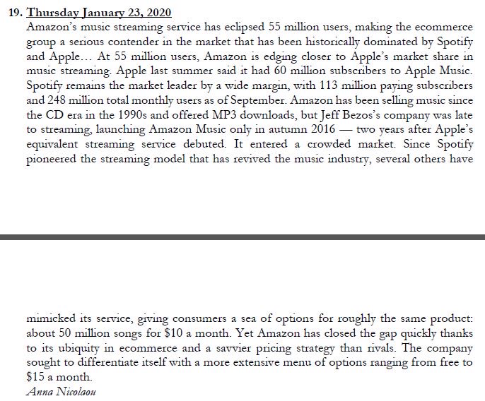

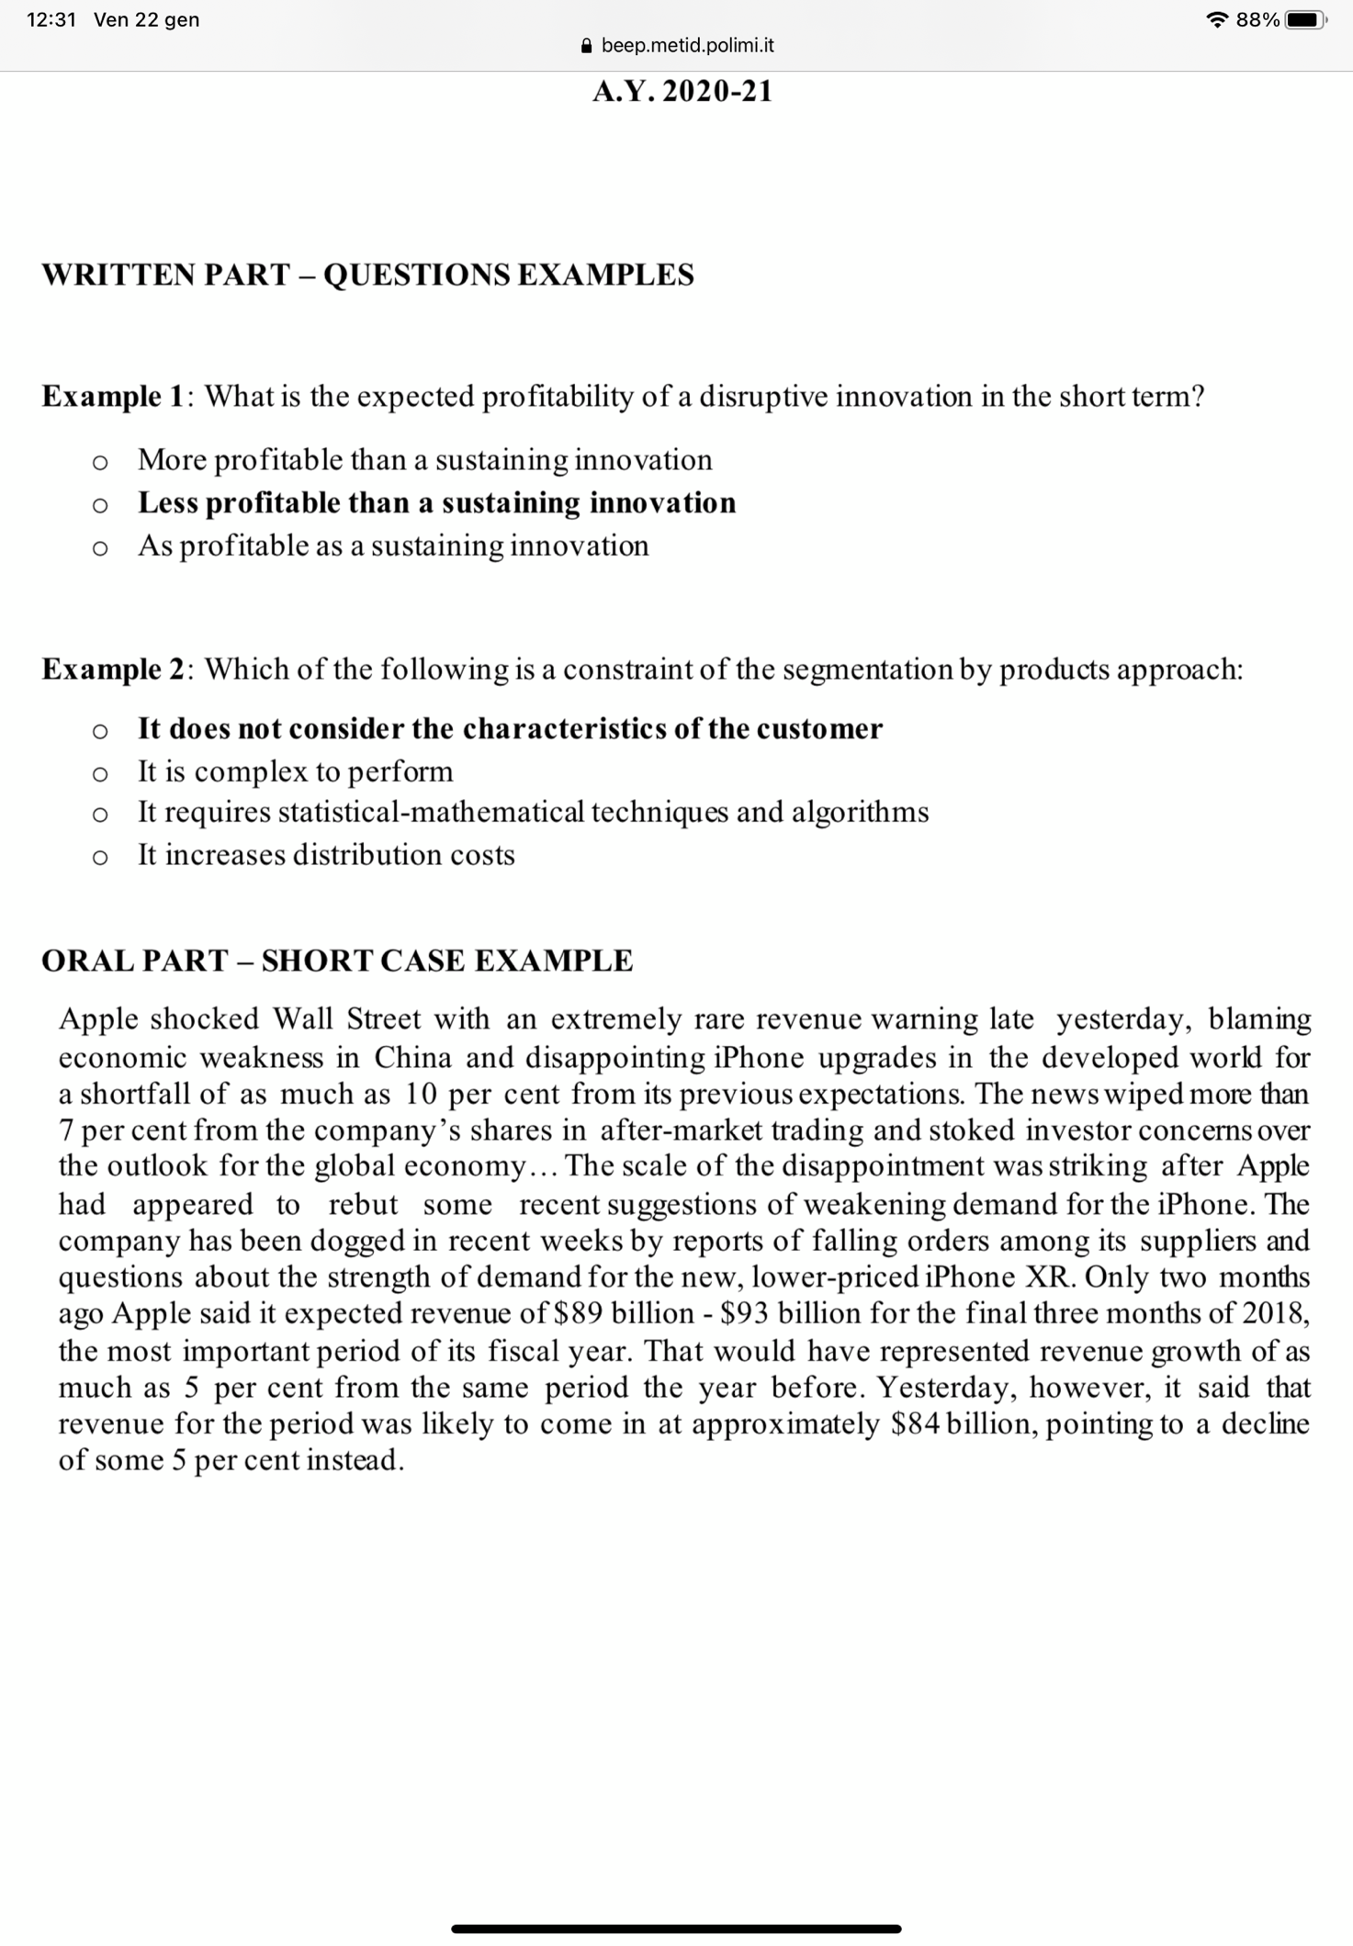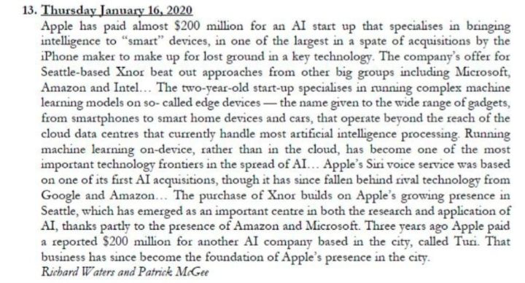

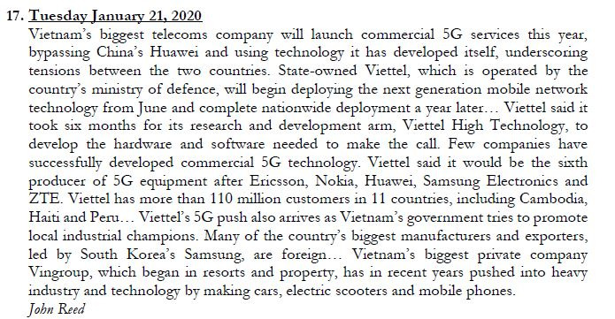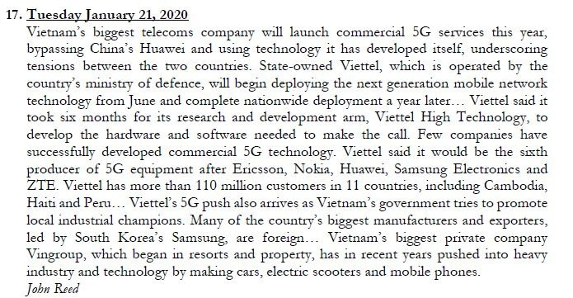



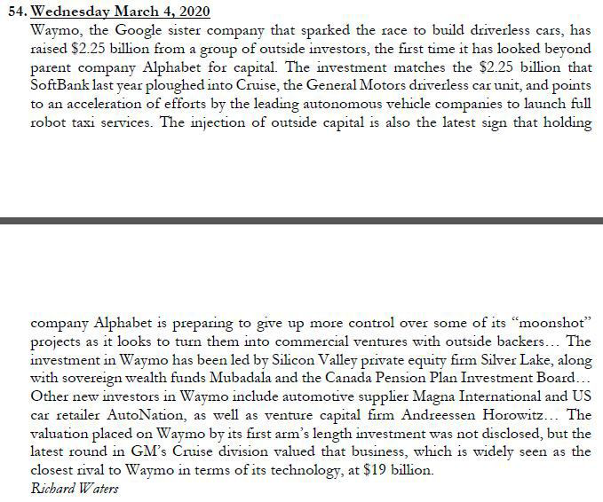



CASE.

San Pellegrino SPA is an Italian company of mineral water and assorted real-fruit sodas produced in San Pellegrino Terme,Province of Bergamo, Lombardy, Italy. San Pellegrino mineral water has been produced for over 600 years, but the company was founded in 1899.

Owned by Nestlé since 1997, Sanpellegrino has ten production sites in Italy, including the headquarters, controls many other brands in the mineral water sector (eg Levissima, Recoaro, Vera, Cream). The company employs a total of about 1,850 employees, with a turnover of more than 900 million euro, with a double digit increase in seals in 2015. In Italy the San Pellegrino Brand’s are in the top quality segment of the market. Outside of Italy, San Pellegrino is marketed as somewhat of a luxury. San Pellegrino is now exported to most countries in Europe, the Americas, Australasia and the Middle East, as well as Japan, Taiwan and Hong Kong.(145 countries).

CASE

The basic story of how Airbnb came to be is already lore in Silicon Valley and beyond: in October 2007, two unemployed art school grads living in a three-bedroom apartment in San Francisco, needing to make rent, decided on a lark to rent out some air mattresses during a big design conference that came to town and overcrowded the city’s hotels. What is new, though, and what Airbnb specifically has done, is to toss aside the barriers and build an easy, friendly, accessible platform inviting anyone to do it. Unlike on previous websites, Airbnb listings were designed to showcase home renters’ personalities; the company invested in individual professional photography services to make sure the spaces would look lush and inviting; and searching, messaging, and payment were all self-contained, seamless, and friction-free. (Many people suggest that Airbnb is not a technology company, since it traffics in homes and spaces, but it has one of the most sophisticated back-end engineering infrastructures

Why did Airbnb succeed in popularizing short-term rentals while others did not? Much of the explanation lies in the product itself. “Product” is a vague and all-encompassing term in the tech world for everything after the idea: it’s the actual website or app; the way it looks, the way it works, the things it can do, the engineering that powers it, and the way you use it and interact with it. From the start, its founders were emphatic about certain things regarding the website and the experience: specifically, it had to be frictionless, it had to be easy. The listings had to look beautiful. And, based on the famous three-click rule from Steve Jobs —when Jobs conceived the iPod, he wanted it to never be more than just three clicks away from a song—the founders wanted their users to never be more than three clicks away from a booking.